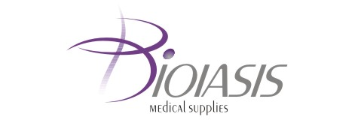

To the FINANCIAL SUPERVISION COMMISSION
33 Shar Planina St.
1303, Sofia

To the BULGARIAN STOCK EXCHANGE – SOFIA JSC
10 Tri Ushi St.
1303, Sofia

To the PUBLIC

DEAR LADIES AND GENTLEMEN,

In July 2009 BIOIASIS Plc has bought back 100 company’s own shares at the price of BGN 119 per share.
The total number of the own shares hold by the company by 31.07.2009 is 202 shares at the price of BGN 119.90 per share.

July 31st 2009 For BIOIASIS Plc: ……………………….. Sofia Georgios Kissas
/Executive Directors/

