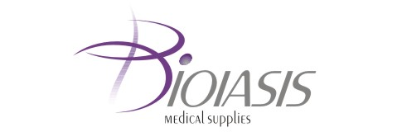

To the FINANCIAL SUPERVISION COMMISSION
33 Shar Planina St.
1303, Sofia

To the BULGARIAN STOCK EXCHANGE – SOFIA JSC
10 Tri Ushi St.
1303, Sofia

To the PUBLIC

DEAR LADIES AND GENTLEMEN,

In September 2009 BIOIASIS Plc has bought back 85 company’s own shares at the average price of BGN 147.105 per share.
The total number of the own shares hold by the company by 30.09.2009 is 387 shares at the average price of BGN 130.29 per share.

Oct. 1st 2009 For BIOIASIS Plc: ……………………….. Sofia Georgios Kissas
/Executive Directors/

